Checkout / Payment Page

Definition
# Source: AI Source: Provided by: [Data Path: Persons Table -> ID Column: 1, Name_En Column: Motasem Essam] -> From: [Chatgpt (GPT‑5 Mini)] on [2/12/2026]
A Checkout / Payment Page is a web page where customers complete a purchase or payment for products or services they’ve selected.

Simple Definition
# Source: AI Source: Provided by: [Data Path: Persons Table -> ID Column: 1, Name_En Column: Motasem Essam] -> From: [Chatgpt (GPT‑5 Mini)] on [2/12/2026]
Checkout Page = the page where users finalize their order and pay.

What a Checkout / Payment Page Usually Includes
# Source: AI Source: Provided by: [Data Path: Persons Table -> ID Column: 1, Name_En Column: Motasem Essam] -> From: [Chatgpt (GPT‑5 Mini)] on [2/12/2026]
- Order summary – list of products/services with prices
- Billing & shipping information – name, address, contact
- Payment options – credit/debit card, PayPal, other gateways
- Promo code / discount field (optional)
- Place Order / Pay Now button
- Confirmation message – after payment is successful

Purpose of a Checkout Page
# Source: AI Source: Provided by: [Data Path: Persons Table -> ID Column: 1, Name_En Column: Motasem Essam] -> From: [Chatgpt (GPT‑5 Mini)] on [2/12/2026]
- Complete the purchase process
- Collect payment and shipping details
- Ensure secure transactions
- Reduce cart abandonment by making the process smooth

Example
# Source: AI Source: Provided by: [Data Path: Persons Table -> ID Column: 1, Name_En Column: Motasem Essam] -> From: [Chatgpt (GPT‑5 Mini)] on [2/12/2026]
- E-commerce website → buying a laptop on Amazon
- Service booking → paying for a consultation or class
- Online event → purchasing tickets for a concert

Difference Between Product Page and Checkout Page
# Source: AI Source: Provided by: [Data Path: Persons Table -> ID Column: 1, Name_En Column: Motasem Essam] -> From: [Chatgpt (GPT‑5 Mini)] on [2/12/2026]
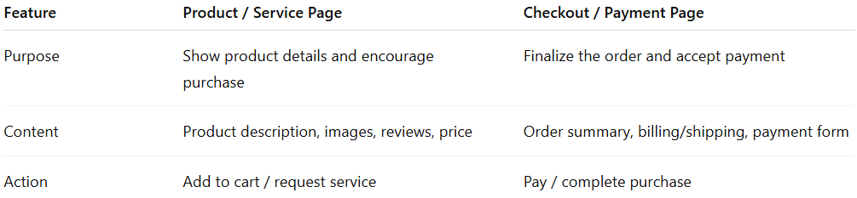
Feature | Product / Service Page | Checkout / Payment Page
Purpose | Show product details and encourage purchase | Finalize the order and accept payment
Content | Product description, images, reviews, price | Order summary, billing/shipping, payment form
Action | Add to cart / request service | Pay / complete purchase

